Following research into documents held by the Chroniclers & those shared by the School Governors. We can make the following comments.
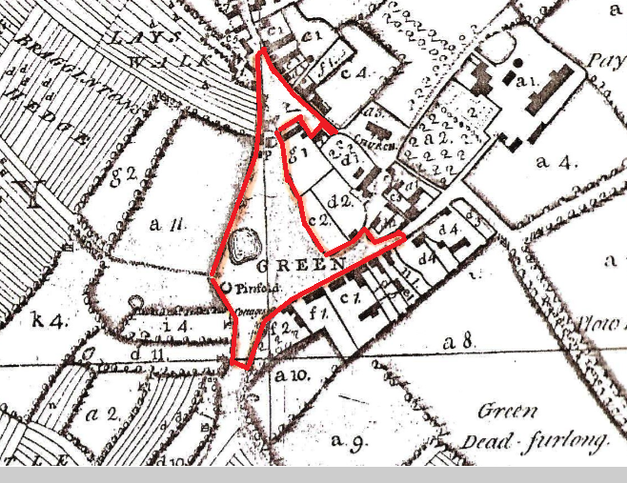
Common Land as of the survey plan of 1772, drawn up by the lords of the Manor, the Dean & chapter of Worcester.7
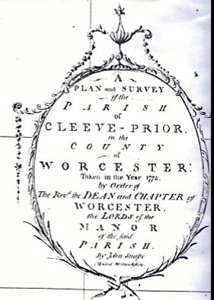
This red line shown on the current village layout
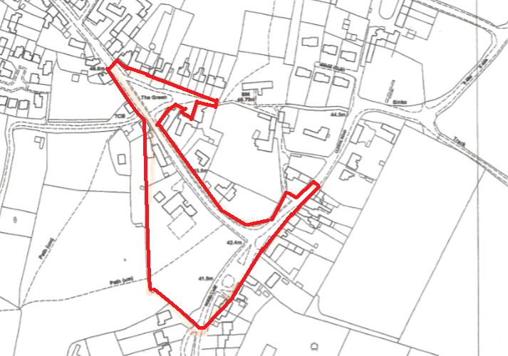

The drive leading up to the church from opposite the pub is not registered land & does not belong to the Hadrill’s or the church.
The front Lawns of the cottages & the cider mill appears to be un-registered & the picture below indicates that the road went up to the front of the cottages, therefore maybe common land.
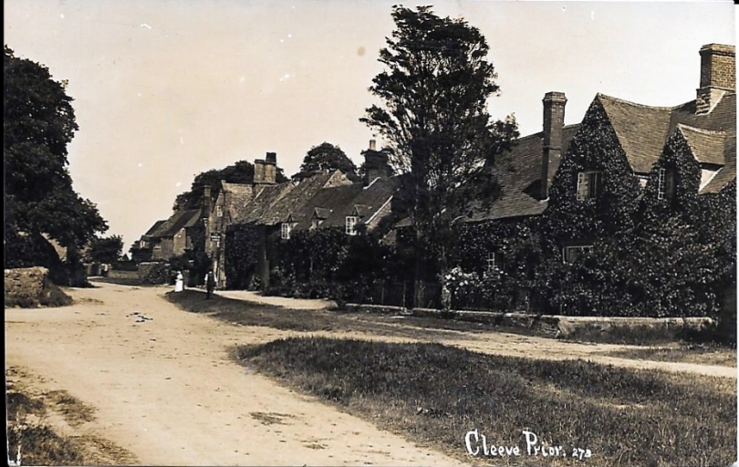
Searches on the Dean & Chapter of Worcester Archive suggest that the land on which the school sits is in trust to the Vicar & Church wardens of Cleeve Prior

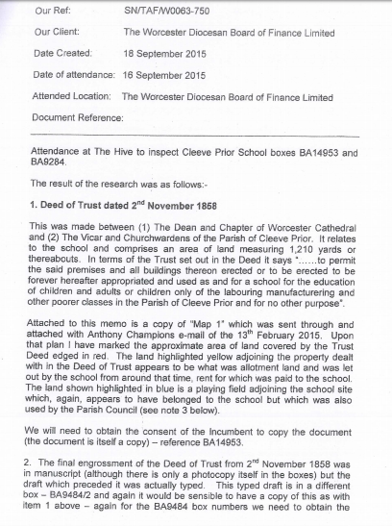
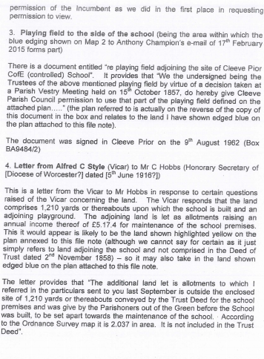
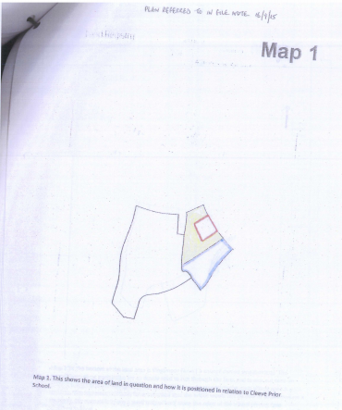
Searches on the Dean & Chapter of Worcester Archive suggest that the land on which the school was given by the parish for the use as a school & this was recorded in a vestry meeting on October 15th 1857.
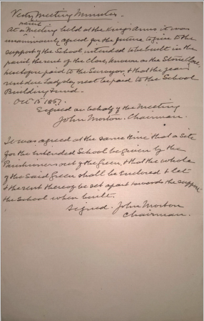
The document states
“At the parish meeting held at the kings Arms it was unanimously agreed for the future to give to the support of the school intended to be built in the parish, the rent of the closes known as Stone Close, henceforth paid to the surveyor, and the years rent due Lady day next be paid to the school for the building fund
October 15 1857
Signed on behalf of the meeting
John Morton Chairman
It was agreed at the same time, that a site for the intended school be given by the Parishioners out of the green, and that the whole of the said green be enclosed and let and the rent thereof be set apart to support of the school the school when built
Signed John Morton Chairman”
This transfer was subsequently made in the form of a deed which put the land in trust with the Vicar & Church wardens of Cleeve Prior as trustees. The trust deed resides in the Church.

The Deed

Plan on 1858 Trust Deed as mentioned above & as can be found below.
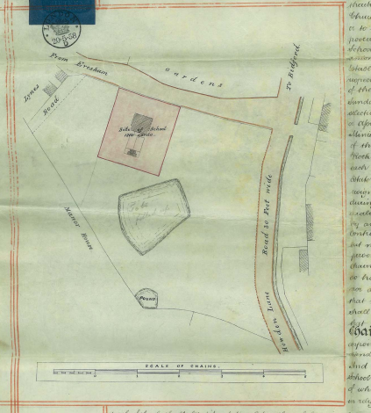

It is our understanding that all lands not previously transferred to other parties were sold to Mr Hiorns, including the Manor and various properties & lands this took place 18th October 1917. The transfer plans, though bad, [held by Ian Robinson] indicate that the common Land was not part of the transfer.
Below is the transfer plan of the land from the Dean & Chapter to the Hiorns [in 1917] the blue road lines are Ian Robinson’s interpretation of the plan].
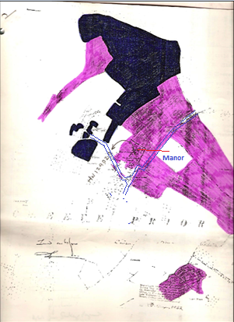

It should be noted that during the passage of time some of the lands designated on the 1772 map are now registered with individual land owners, however, many are not & these are required to be identified.

Ian Robinson

